**Section 1. Set Up Application Insight**

**Note**: Place the following screenshots in the */submission-screenshots/application-insights* directory.

1. Provide screenshots for the following itmes from your Azure portal:
   * Azure Log Analytics Workspace resource  
     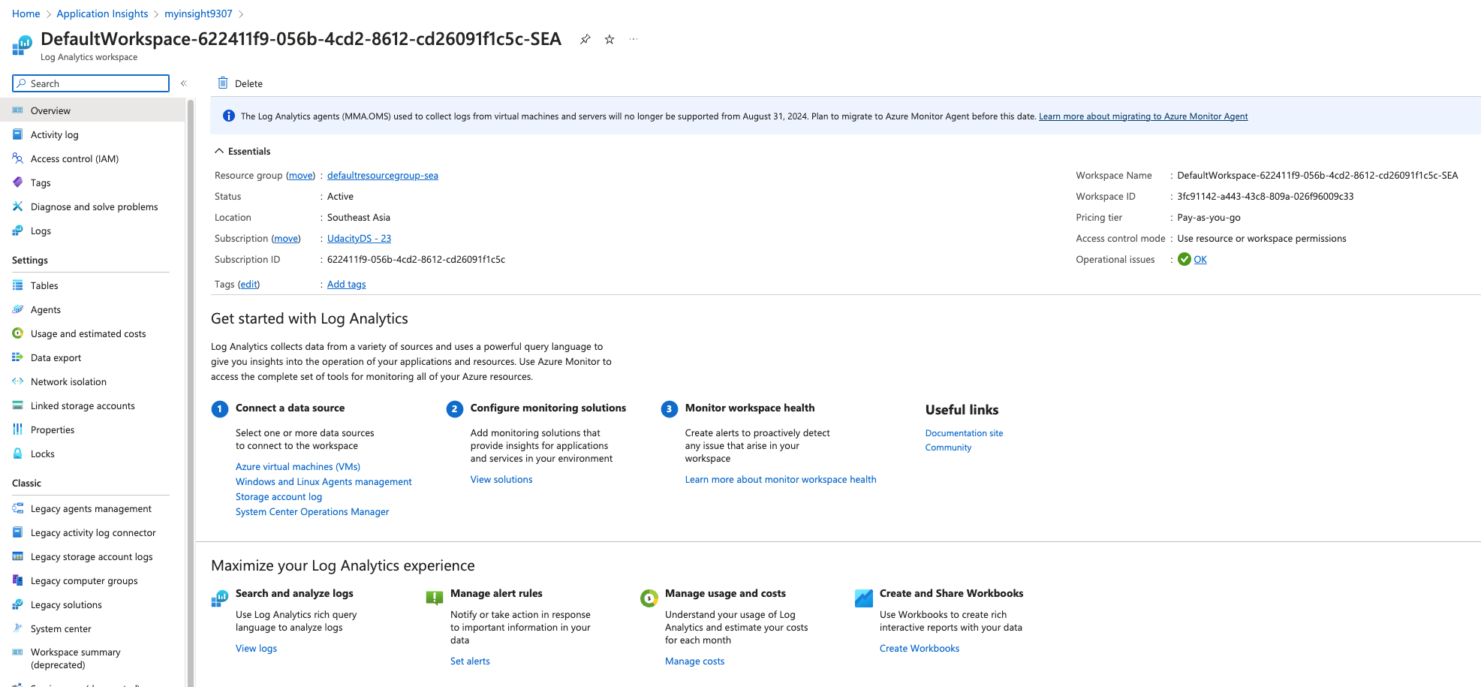
   * Azure Application Insights resource  
     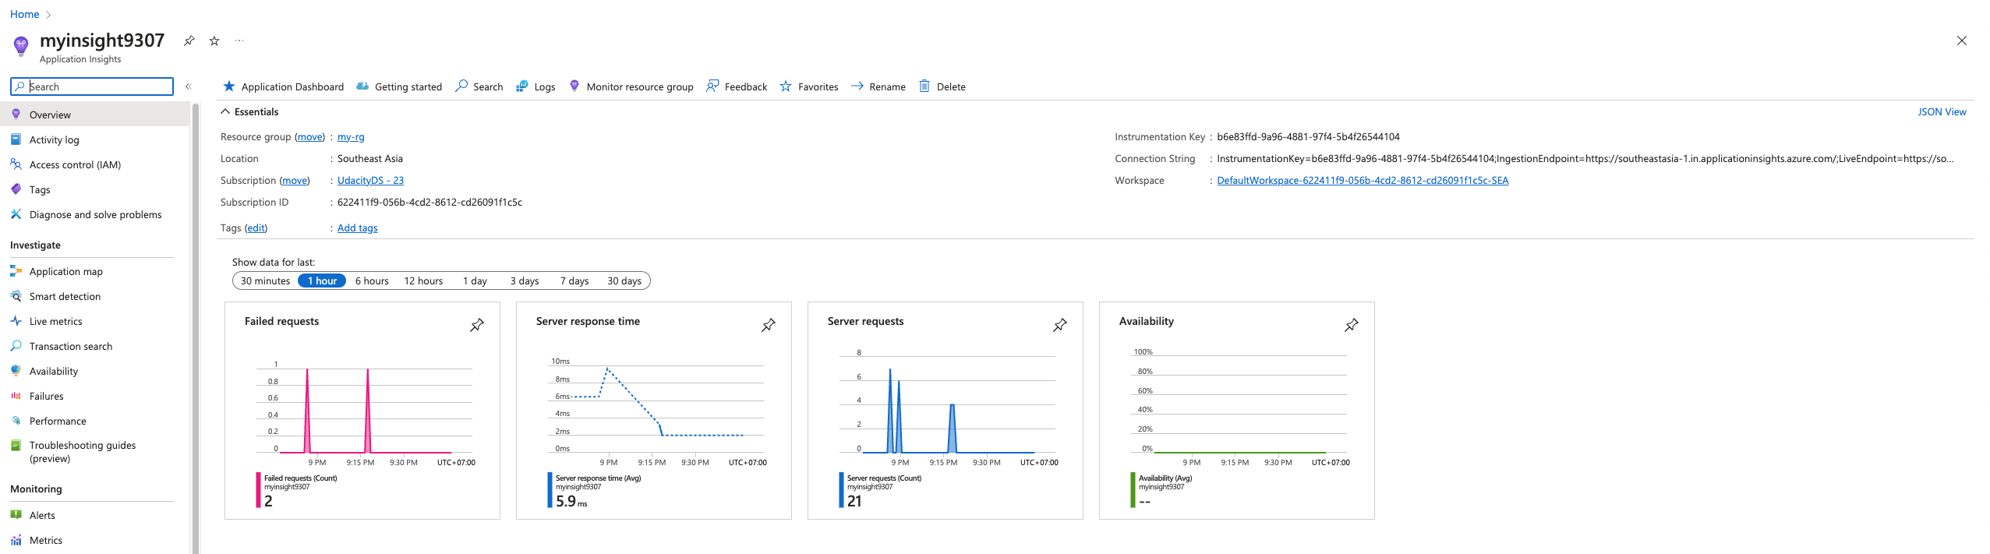
   * Resource group containing your running resources  
     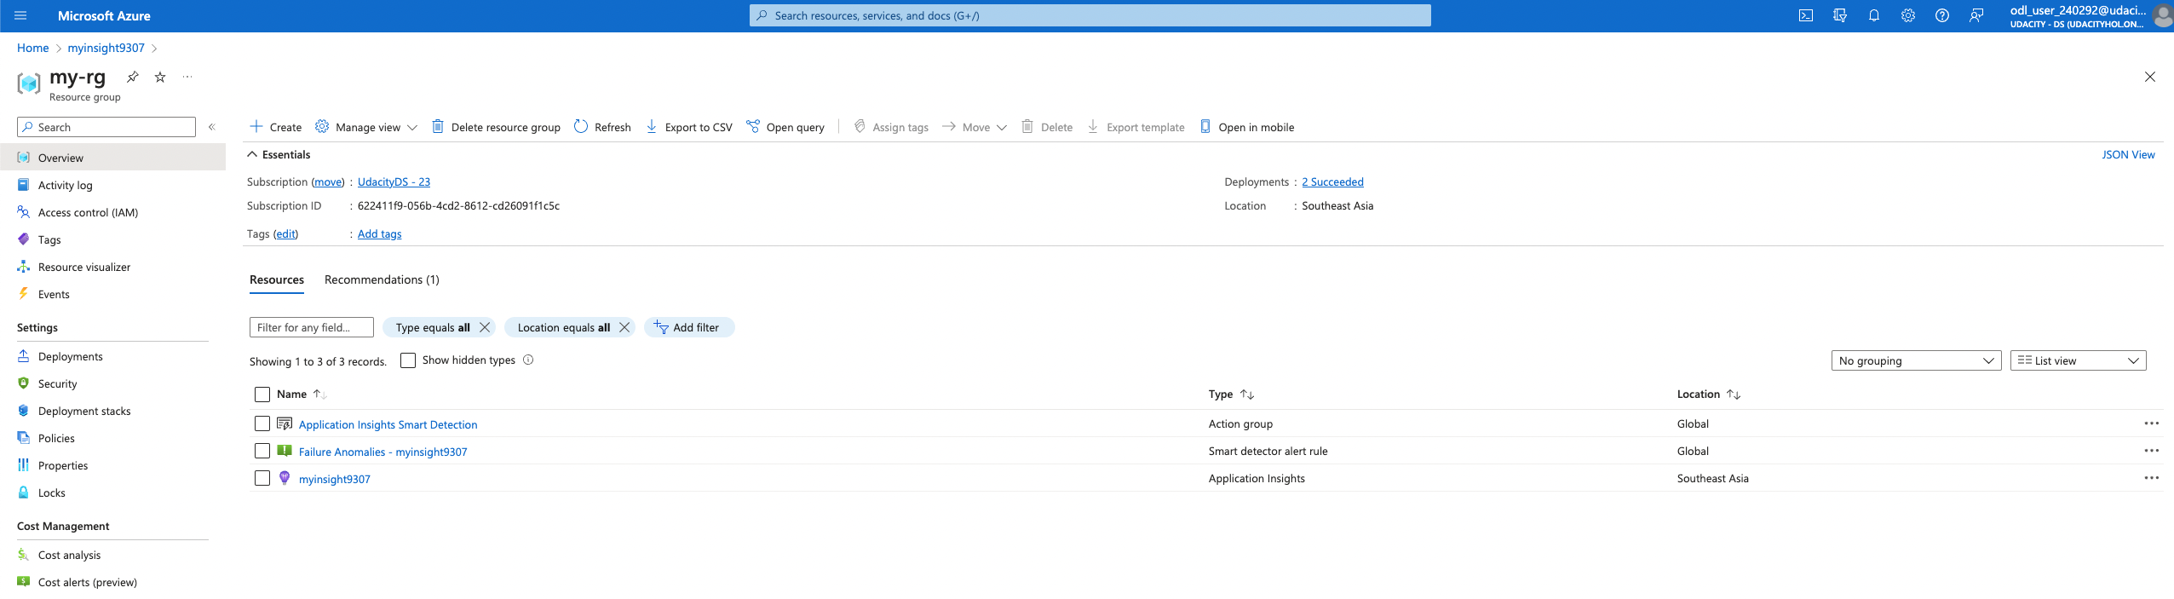
2. Enable the Application Insights monitoring on VMSS. Provide a screenshot of the metrics from the VM Scale Set instance--this will show
   * CPU %,  
     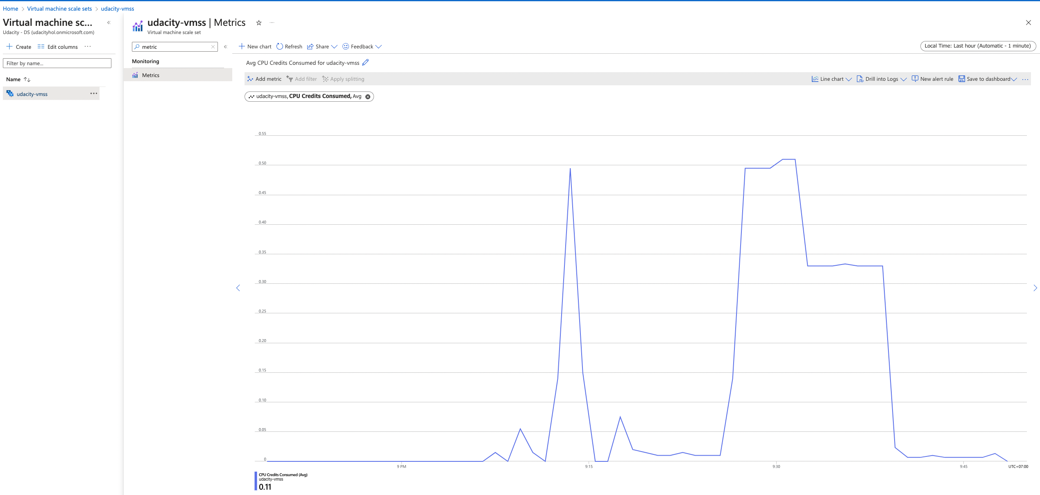
   * Available Memory %,  
     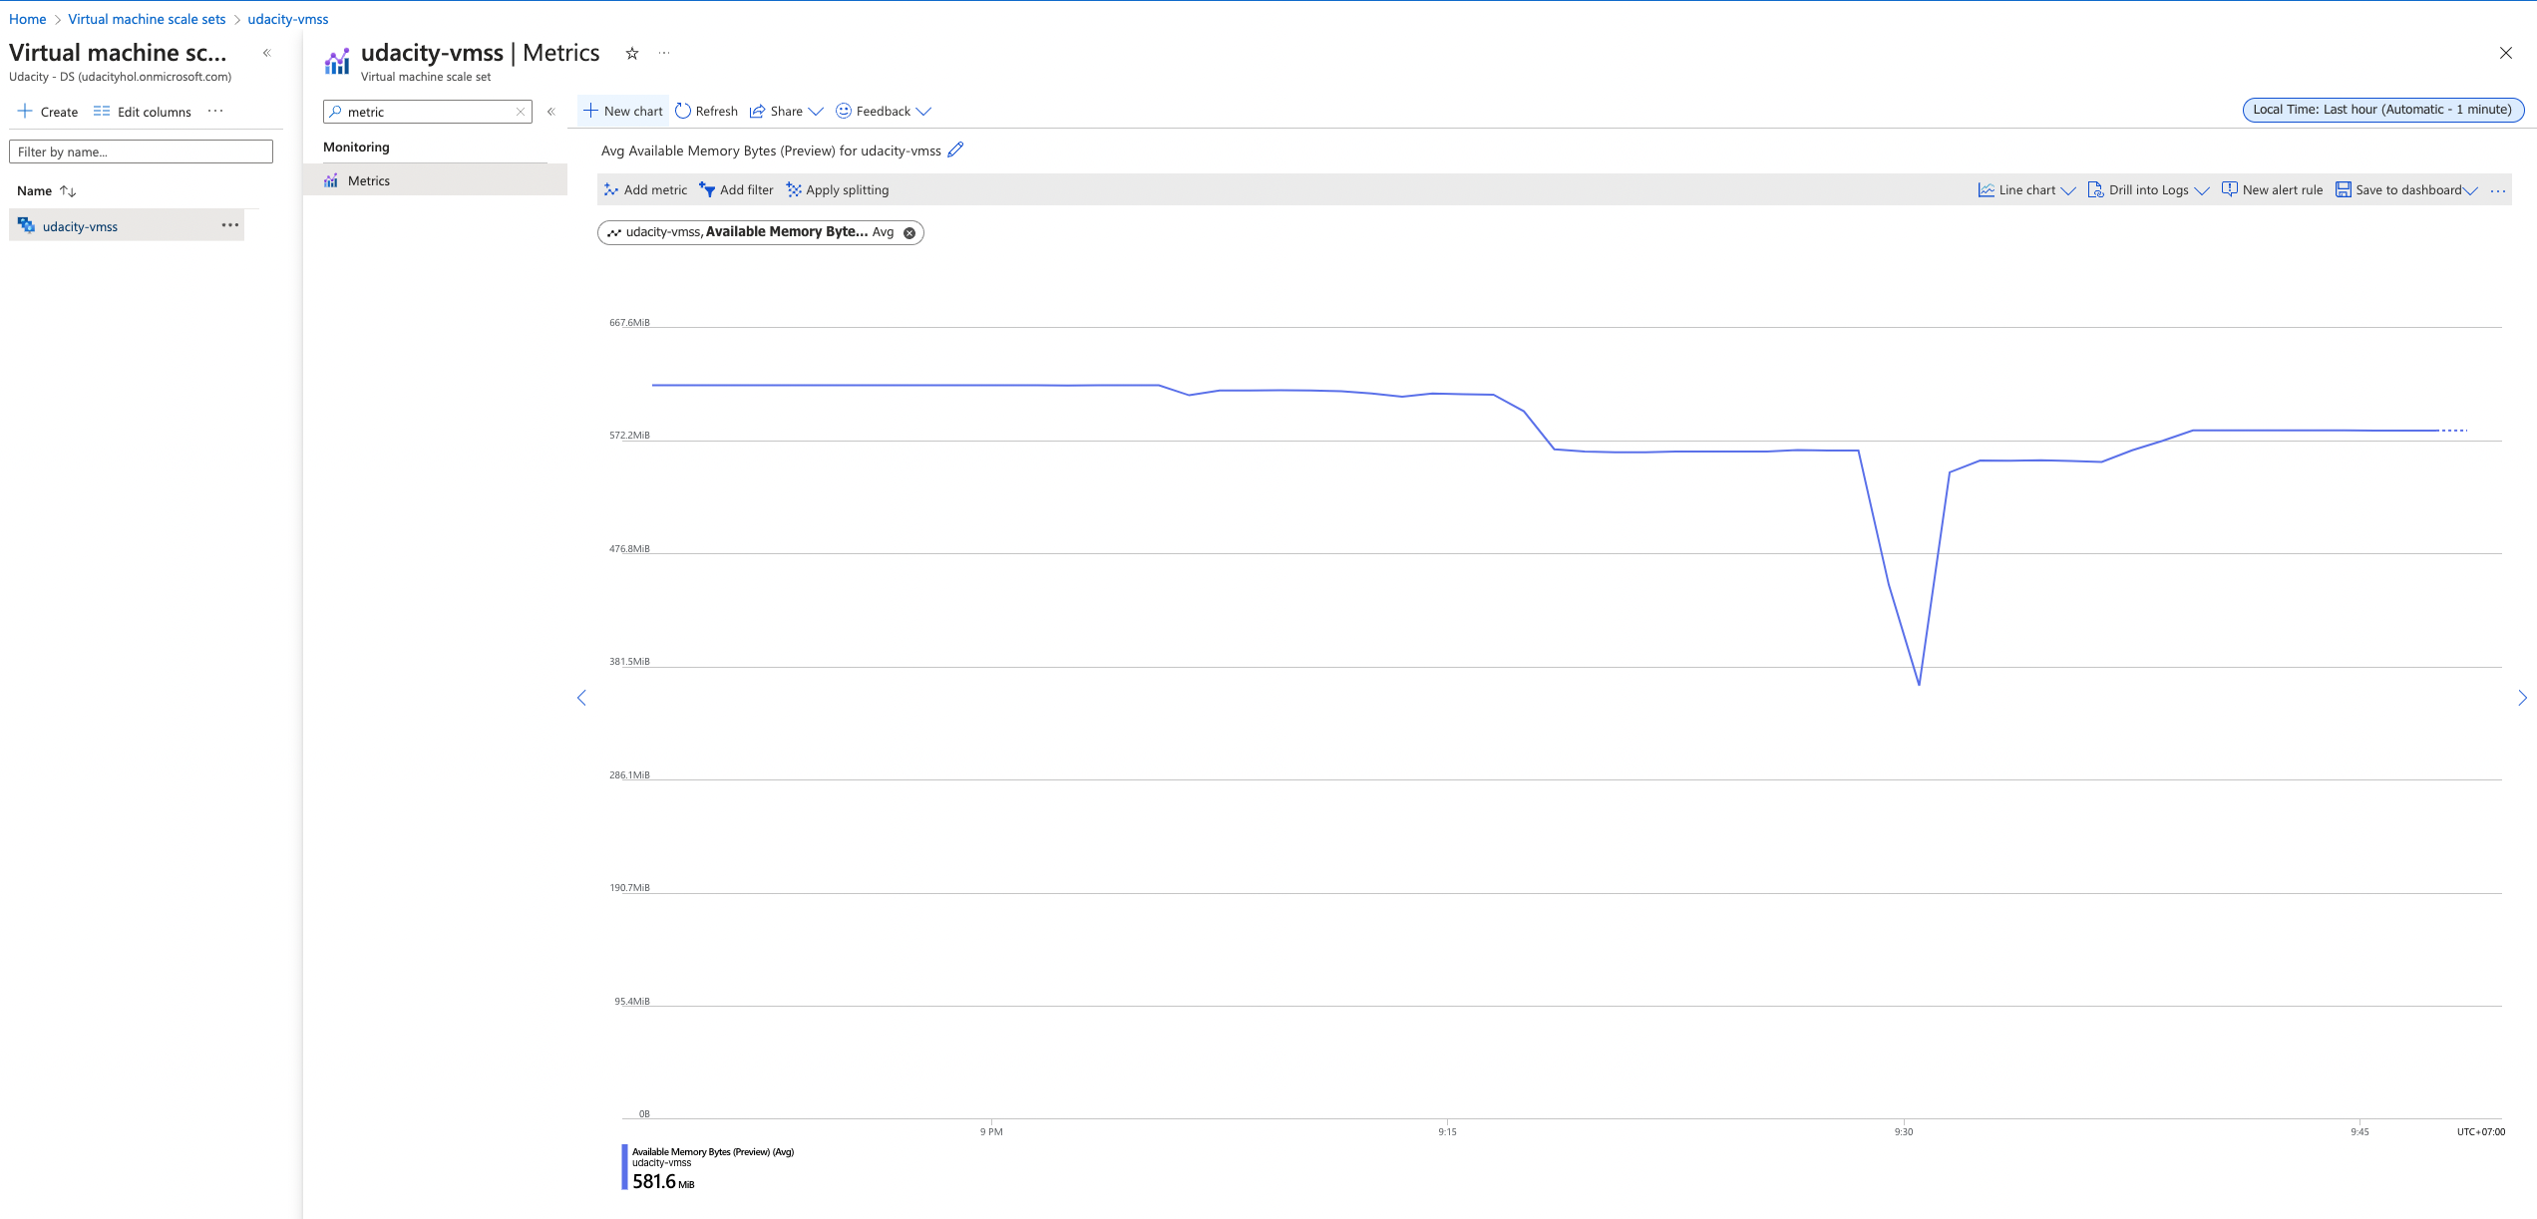
   * Information about the Disk, and  
     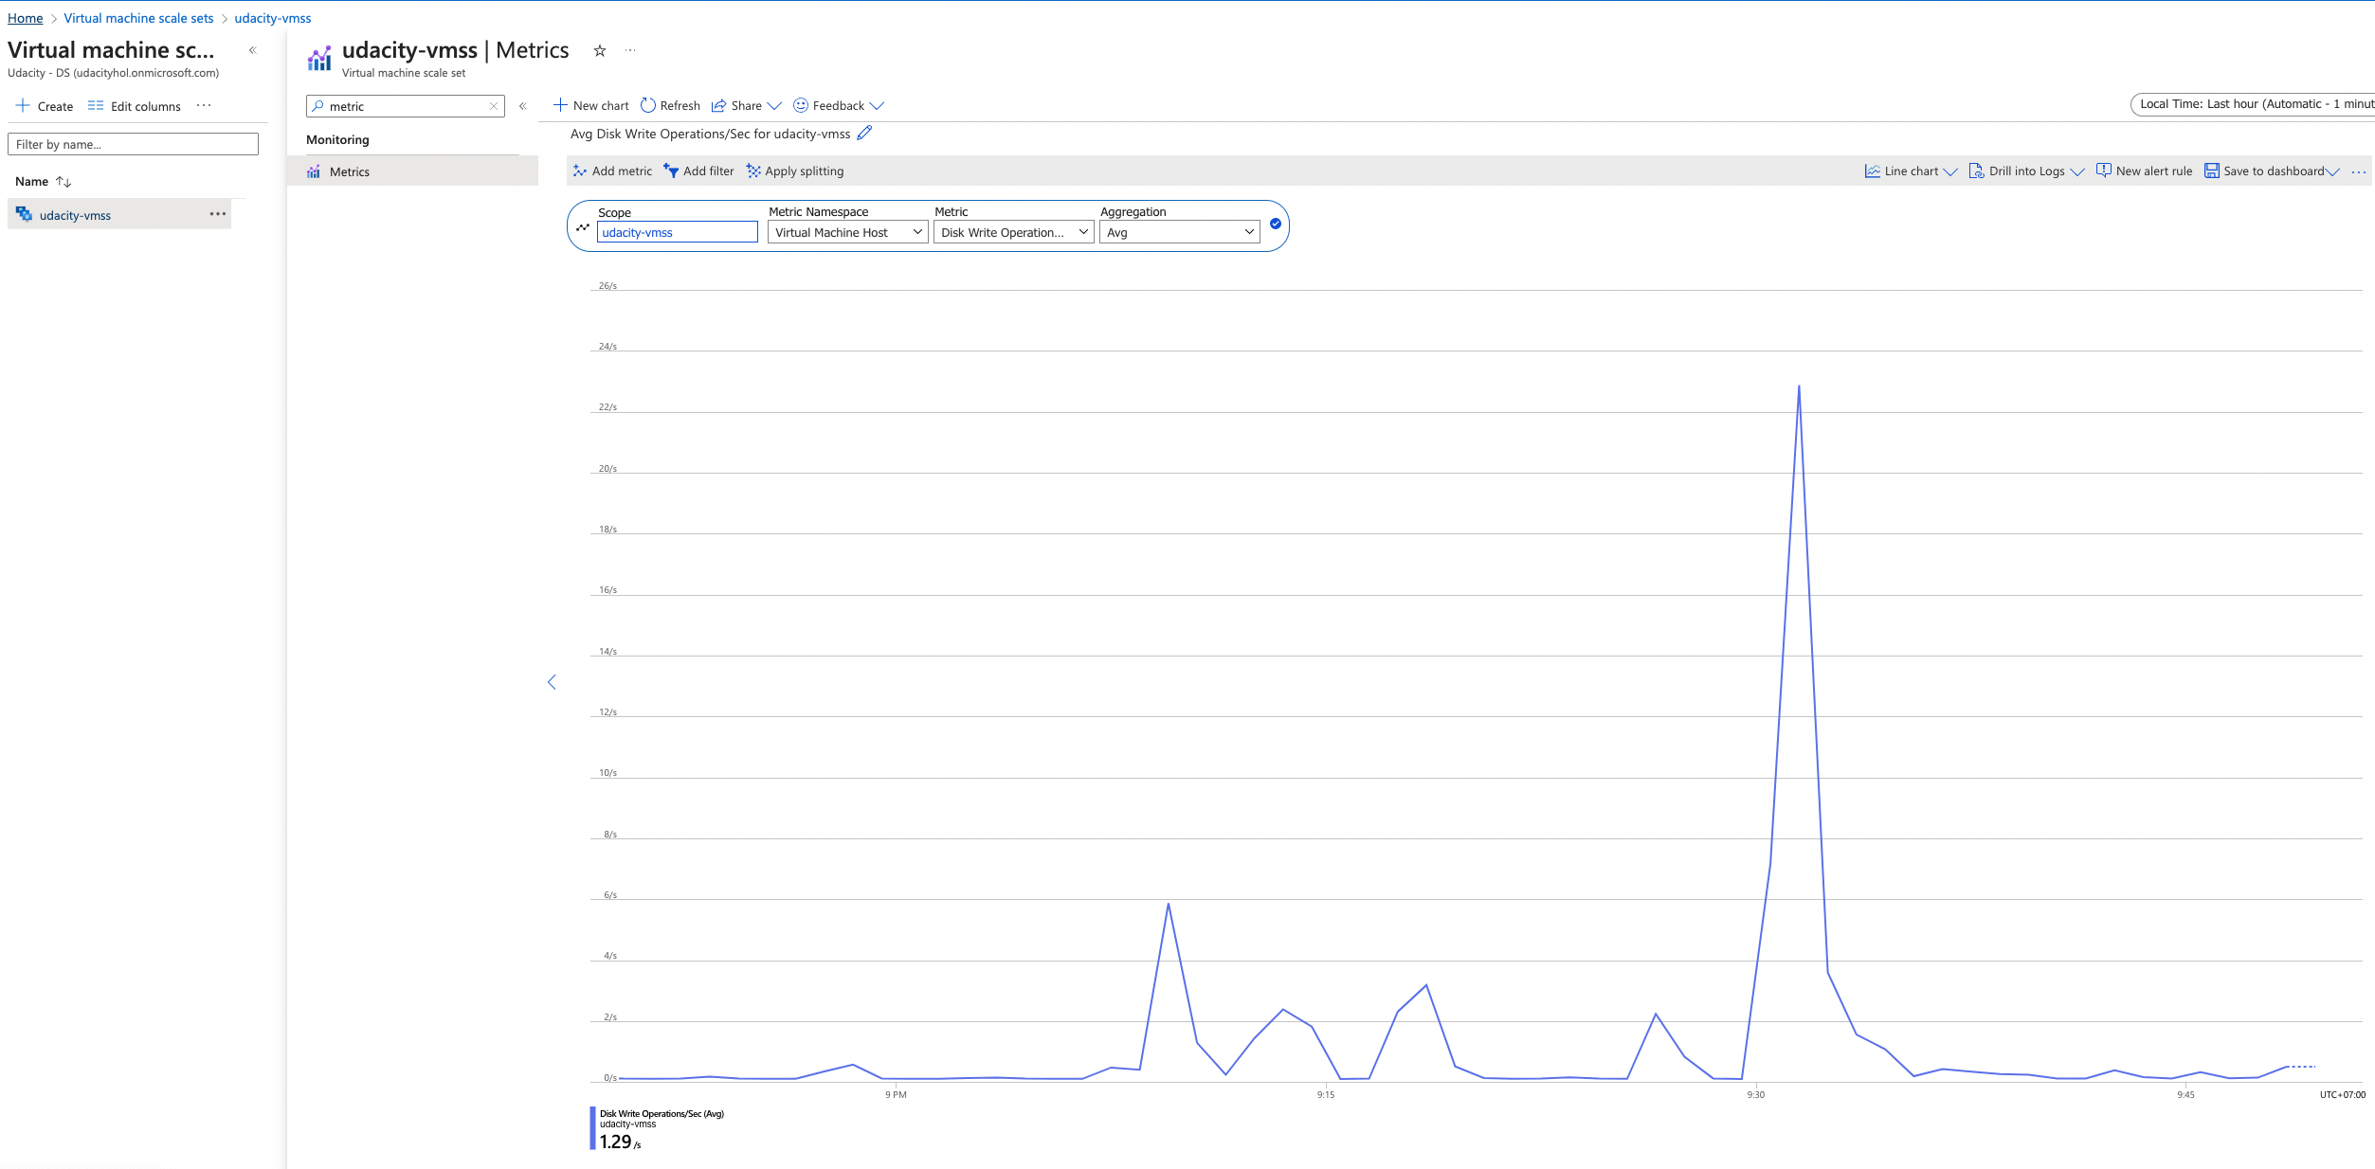
   * Information about the bytes sent and received.  
       
     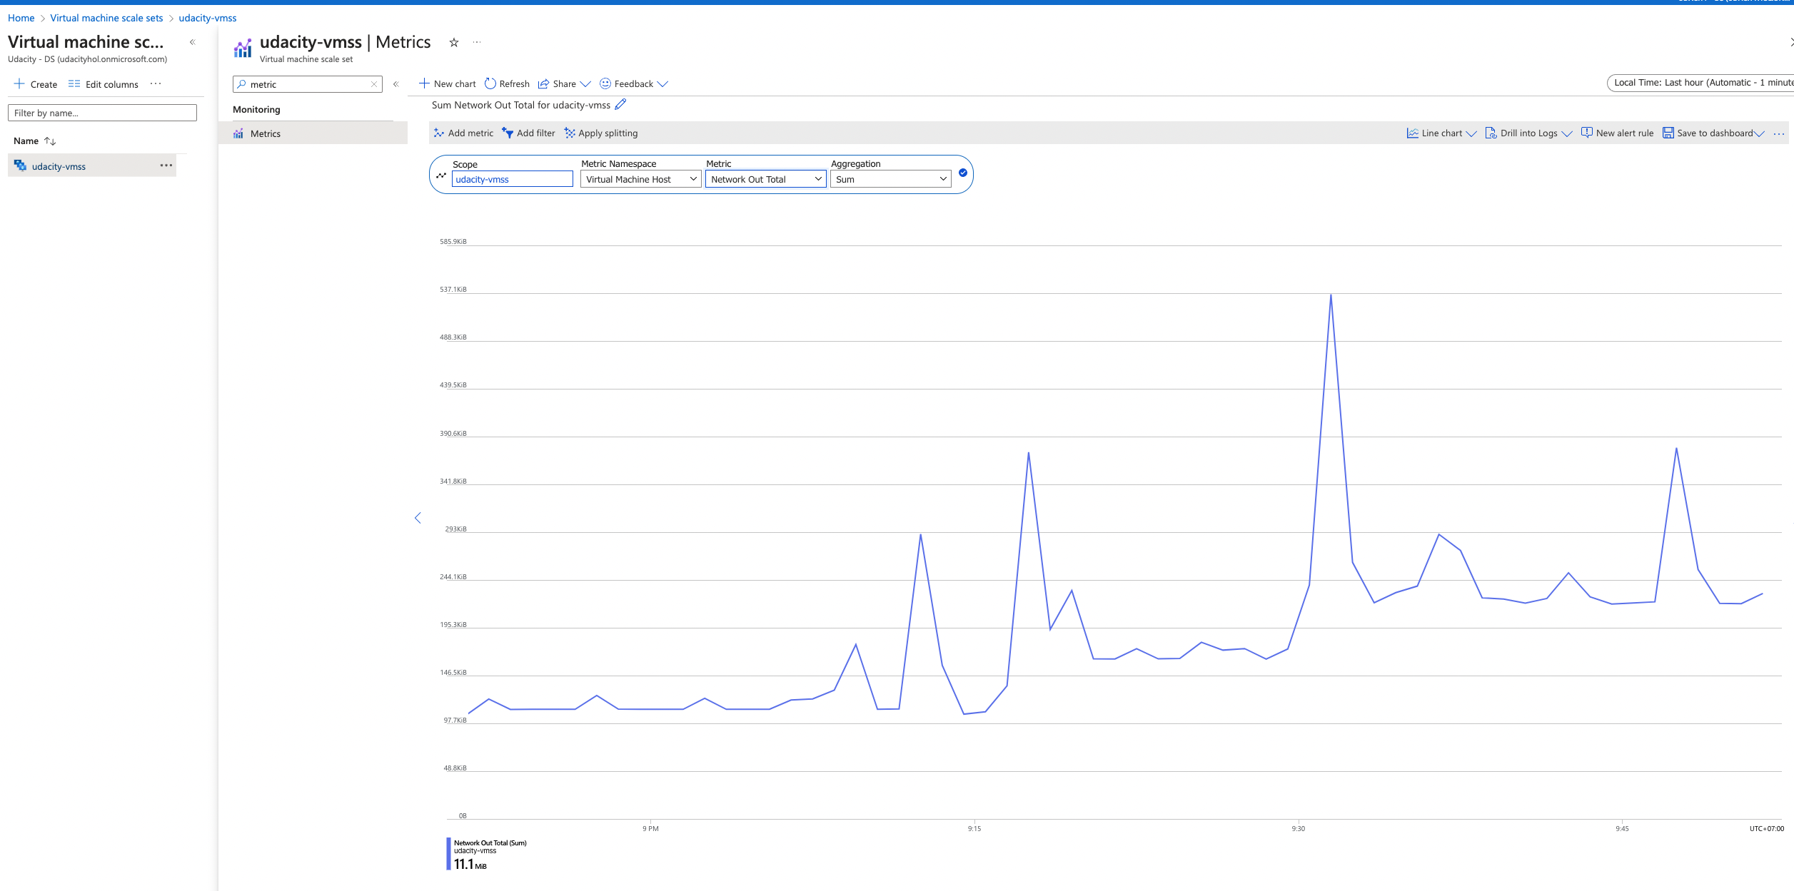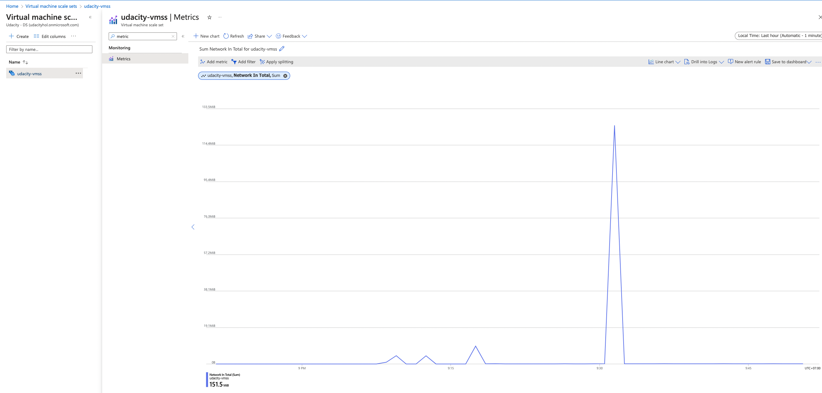

There will be 5-7 graphs which display this data.

**Section 2. Analyzing Performance Metrics**

1. You will submit a zipped folder with all files OR your GitHub repo on the last page of this project lesson. It will have main.py as part of the final submission (see the last page). The main.py should contain the code for the Application Insights telemety data.
   * Import and reference the correct libraries for Application Insights.
   * Add code to reference the Application Insights Instrumentation key. The objects that will use this key include: exporter, tracer, flask middleware, and logger. References to each of these objects should be found in the def index() function.
2. You should be able to view the collected data in Azure Application Insights & Azure Log Analytics. Provide screenshots of the following:
   * Application Insight Events which show the results of clicking 'vote' for each 'Dogs' & 'Cats'  
     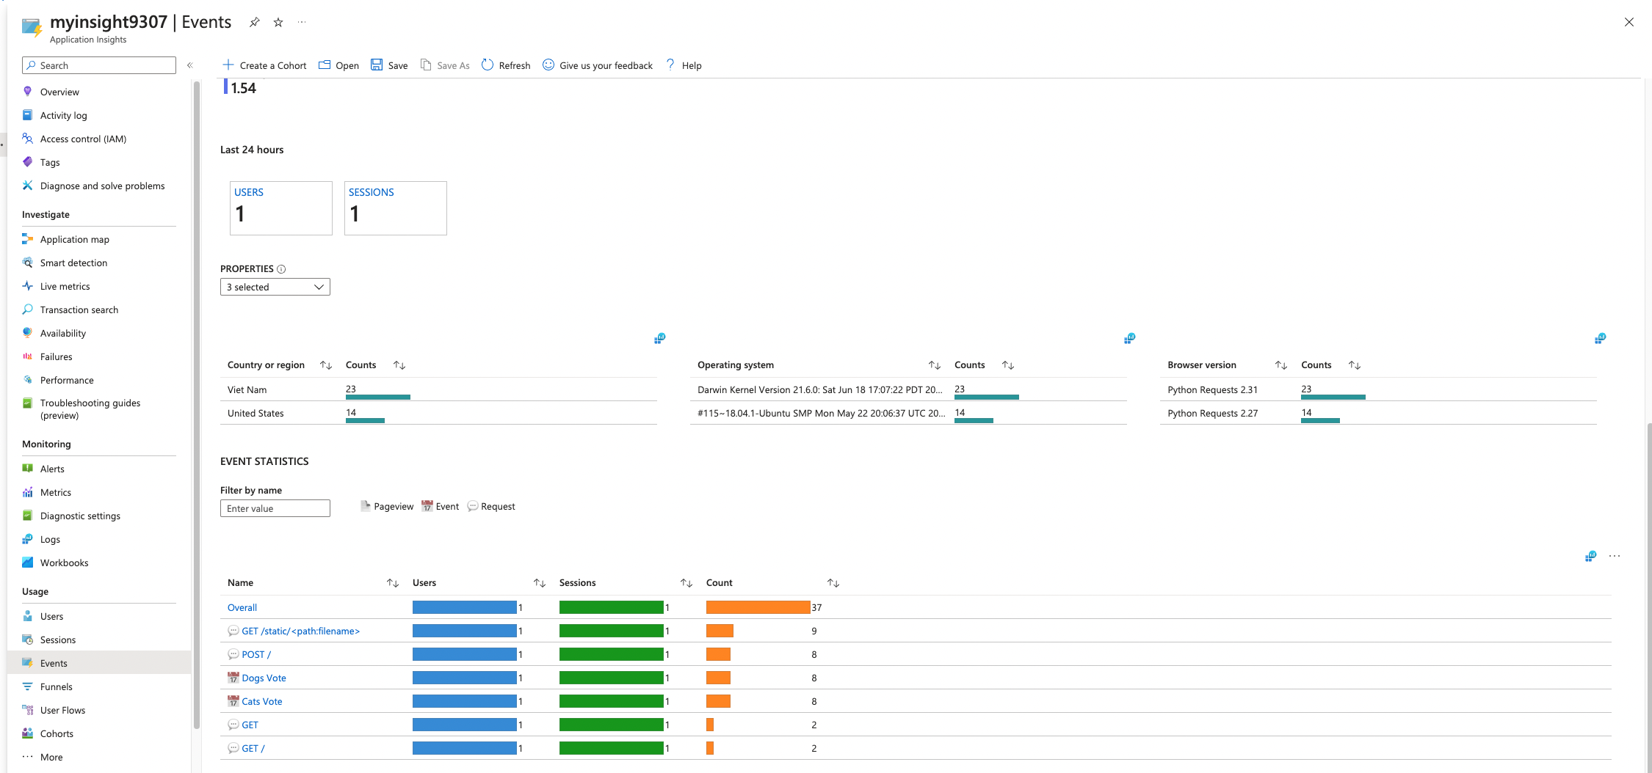
   * The output of the traces query in Azure Log Analytics.  
     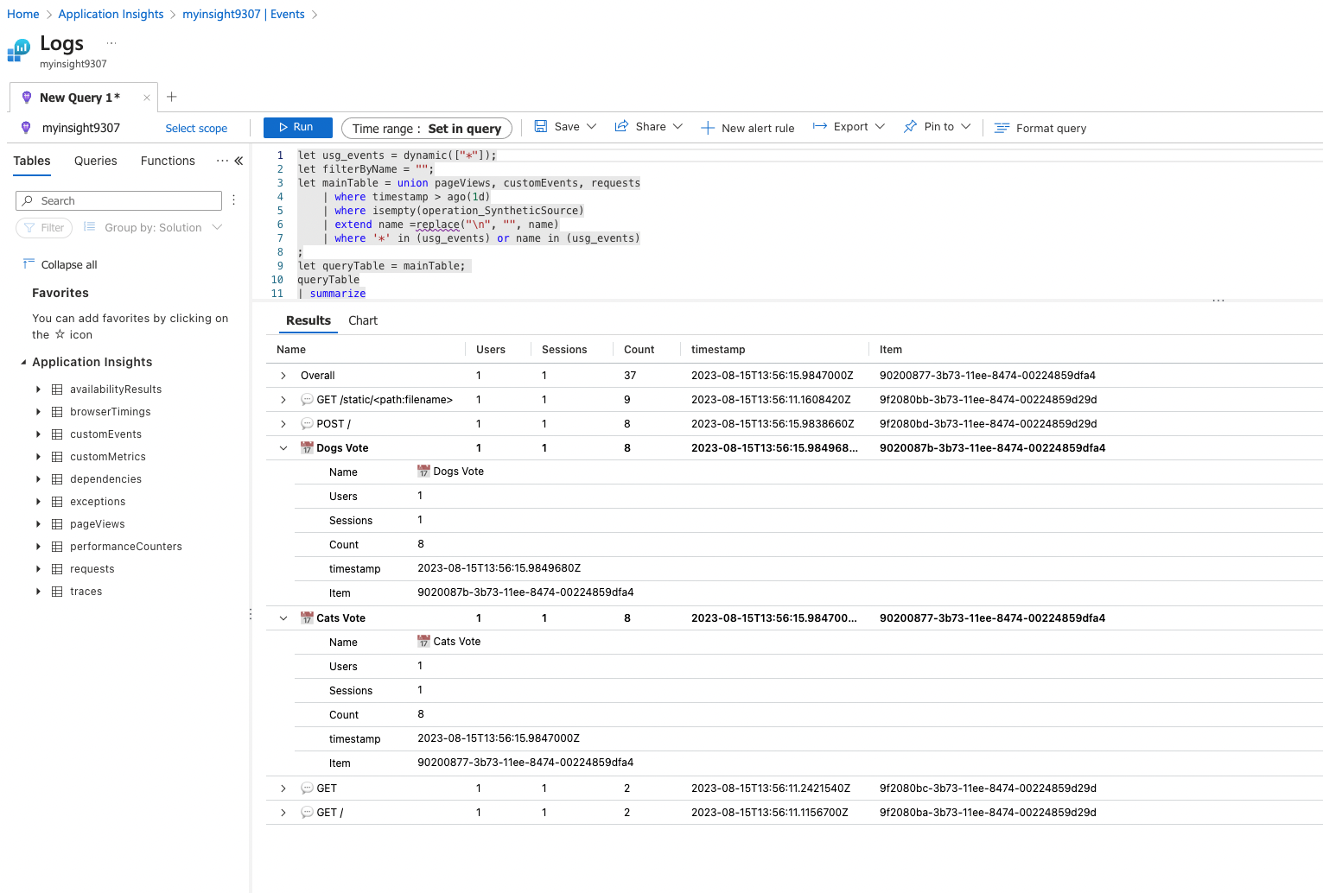
   * The chart created from the output of the traces query.  
     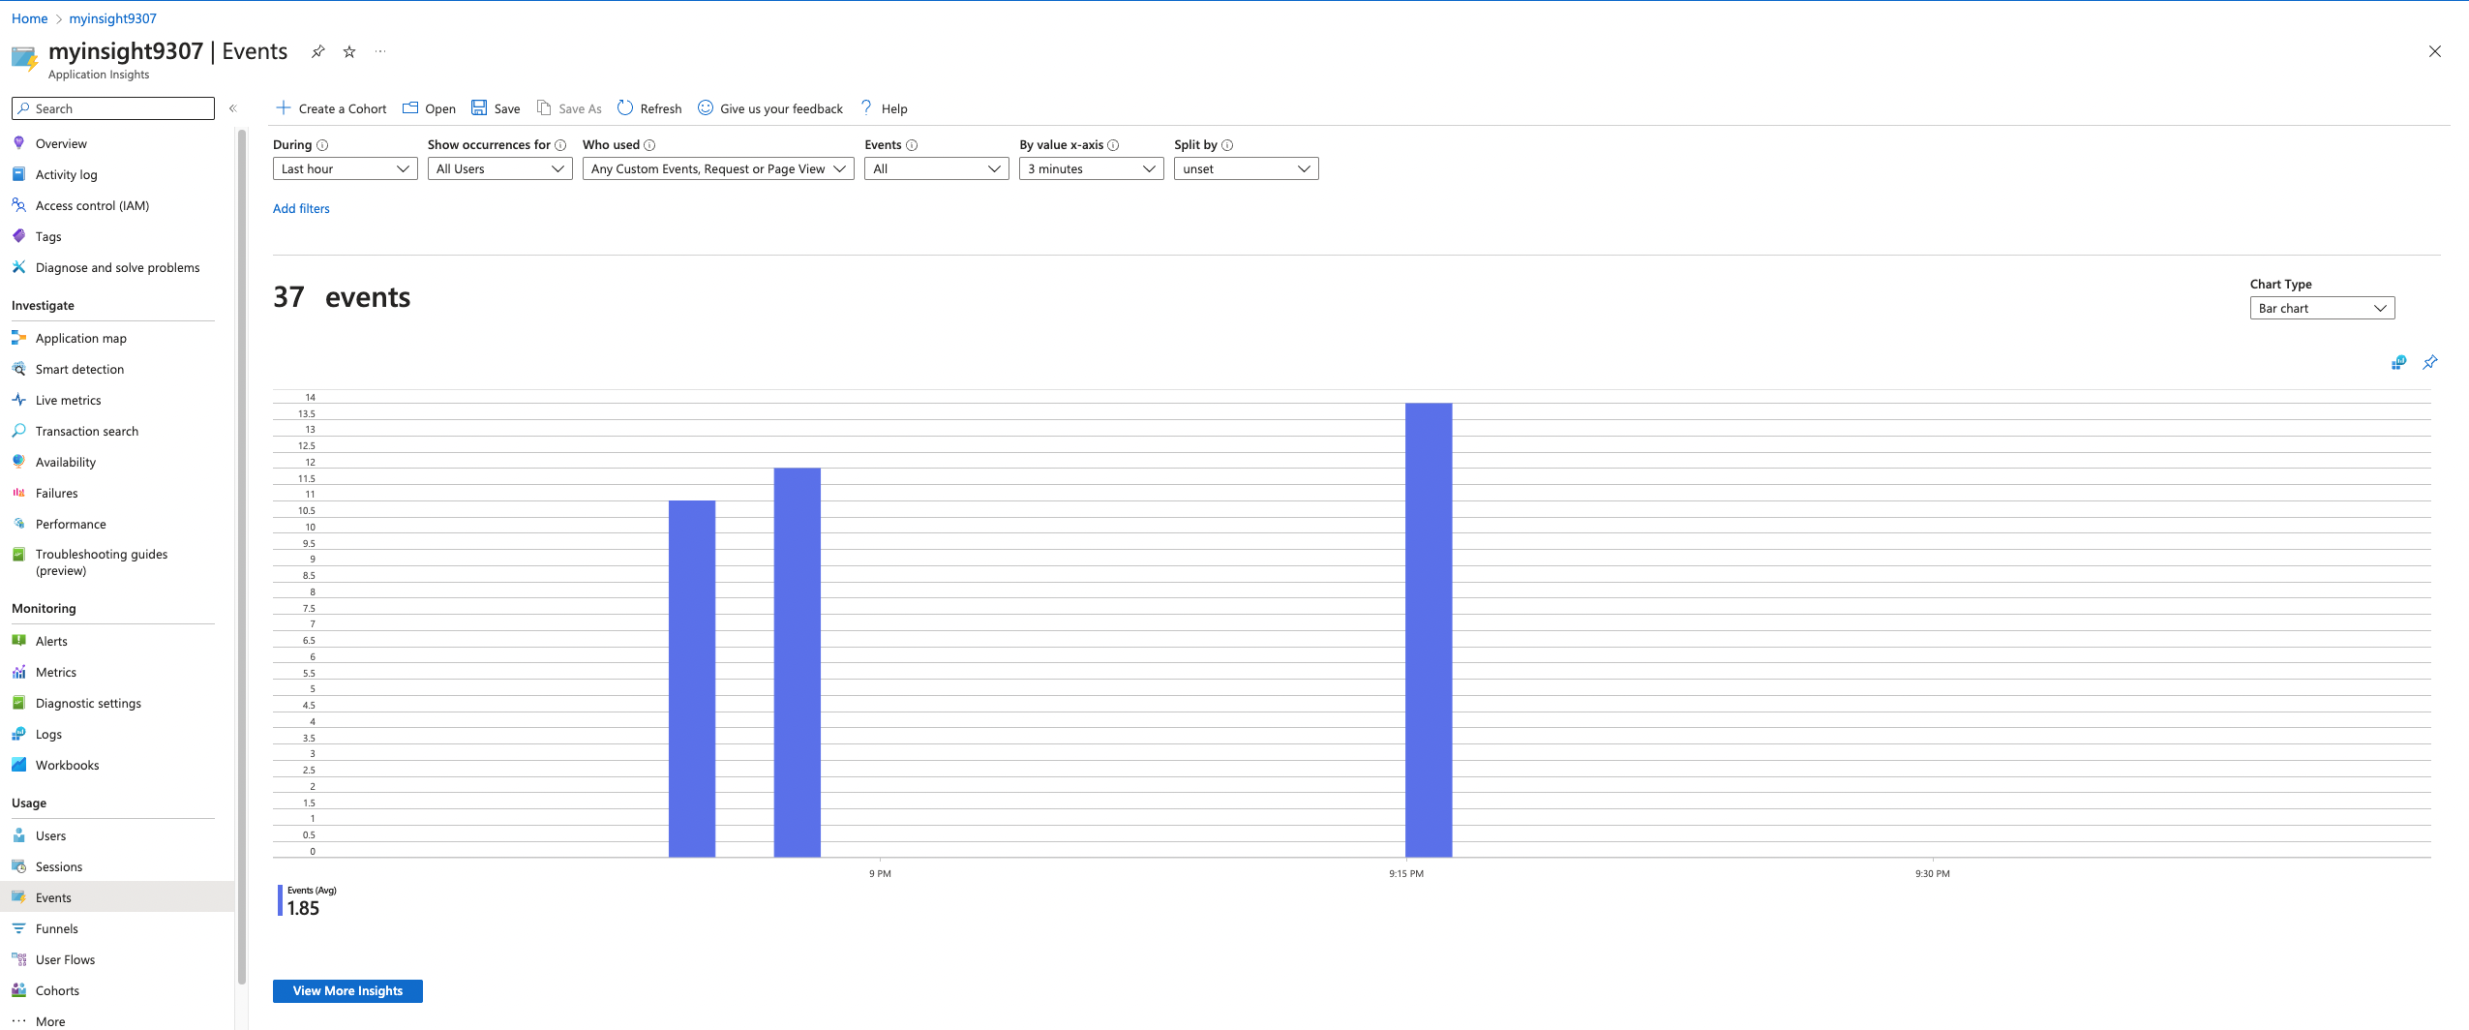

**Section 3. VM Autoscaling**

**Note**: Place the following screenshots in the */submission-screenshots/autoscaling-vmss* directory.

Provide screenshots for the Autoscaling of the VM Scale Set which include:

1. You will enable the auto scaling rule for the VM Scale Set. Provide a screenshot showing the conditions for which autoscaling will be triggered. This can be found in the 'Scaling' item in the VM Scale Set.  
   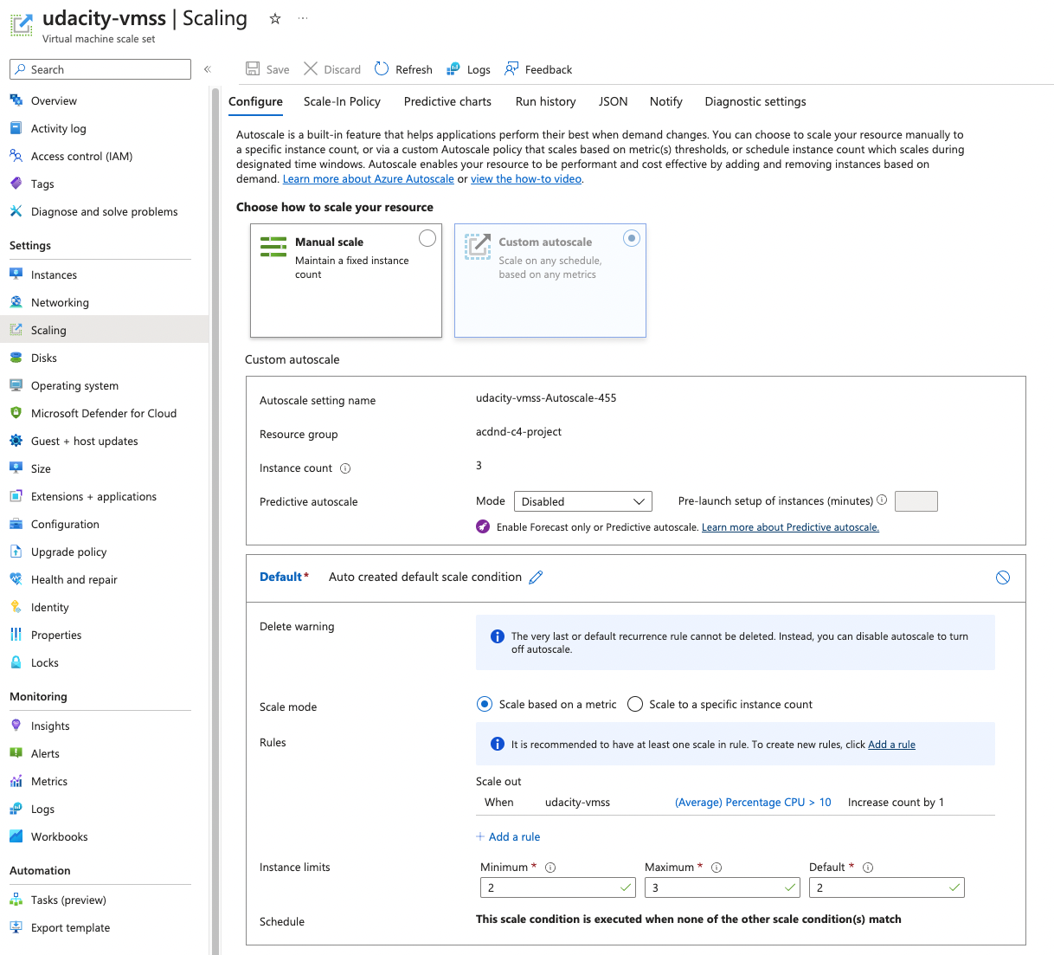
2. Next, you will trigger the VM Scale Set auto scale rule. Provide the following screenshots:
   * The Activity log of the VM scale set which shows that it scaled up with timestamp.  
     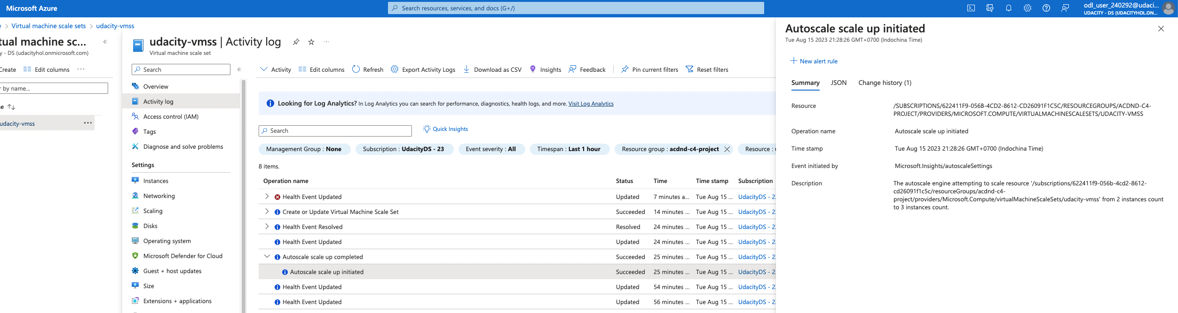
   * The new instances being created. This will be shown by the word 'Creating' next to the instance number. **(Unfortunately, the time I capture it, the VM is created)**  
     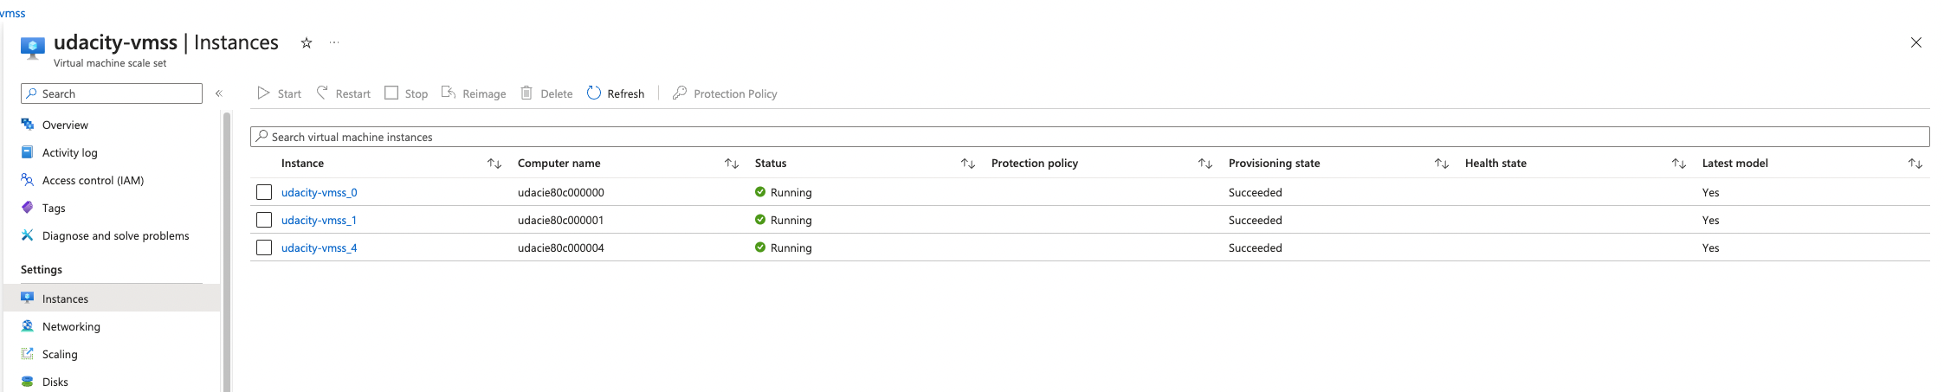
   * The metrics graph showing the load increasing, then decreasing once scaled up, including a timestamp.  
       
     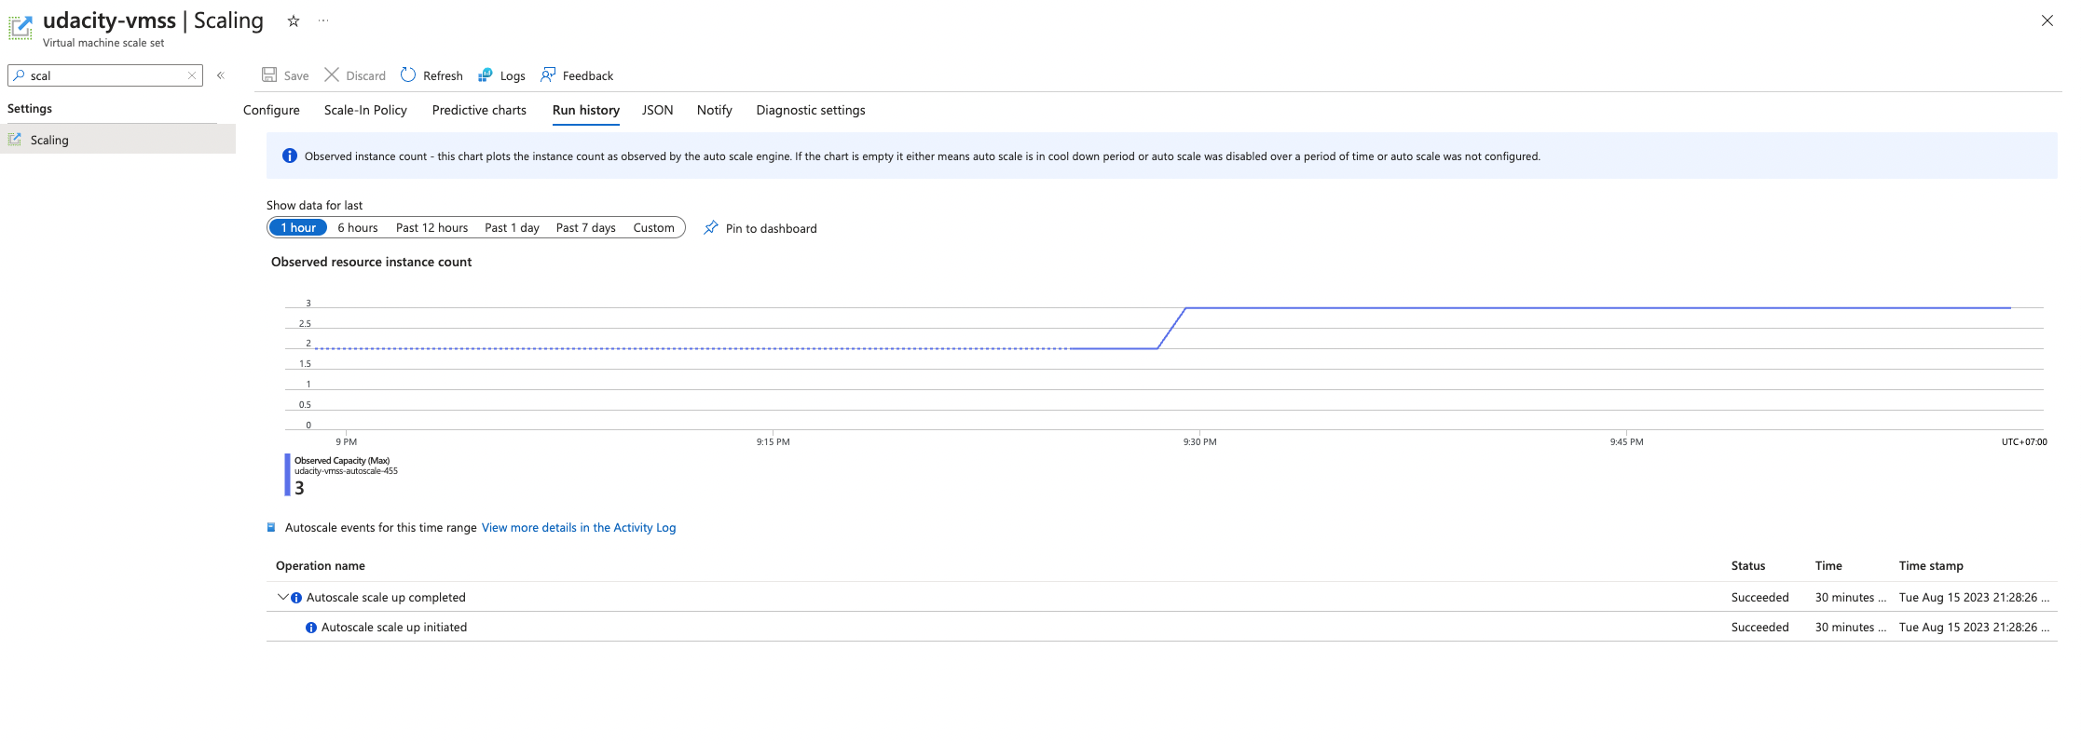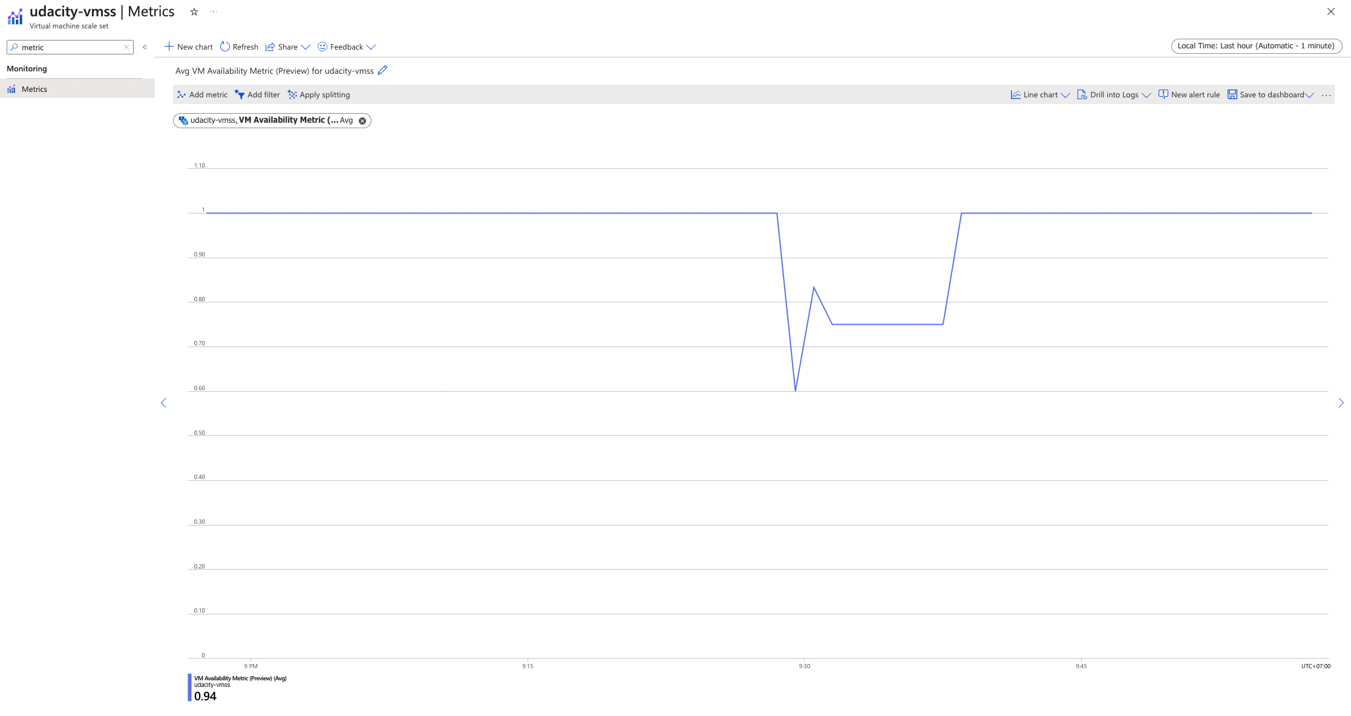

**Tip:** The timestamps from the screenshot of the metrics and the screenshot of the Activity Log are close (within 10 minutes or so).

**Section 4. Kubernetes**

**Note**: Place the following screenshots for Kubernetes Cluster in the */submission-screenshots/kubernetes-cluster* directory

1. Capture a screenshot showing Application Insights is enabled on the AKS cluster.  
   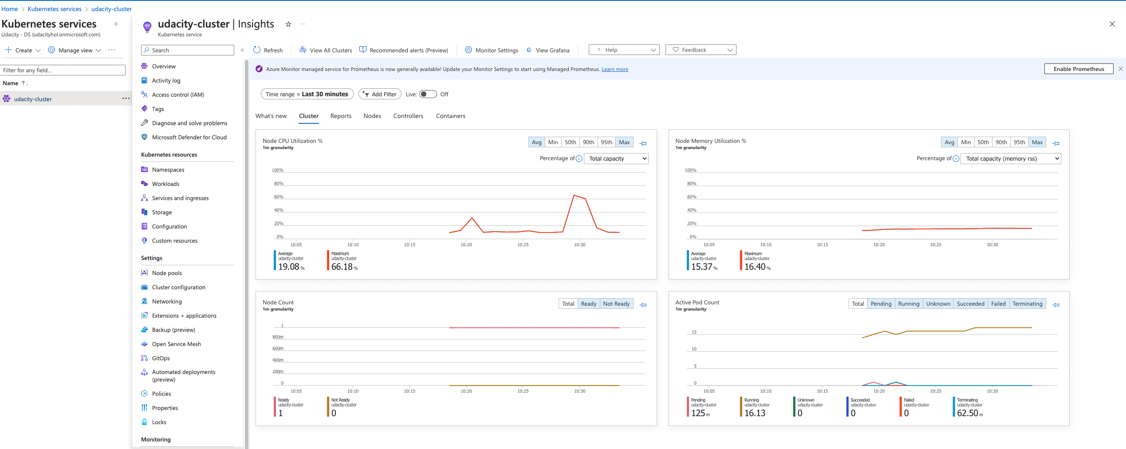
2. Create an Azure Alert in Azure Monitor that would trigger when the number of AKS pods increases beyond a certain threshold. Provide a screenshot of the Azure Alert and email sent when the alert is triggered.  
   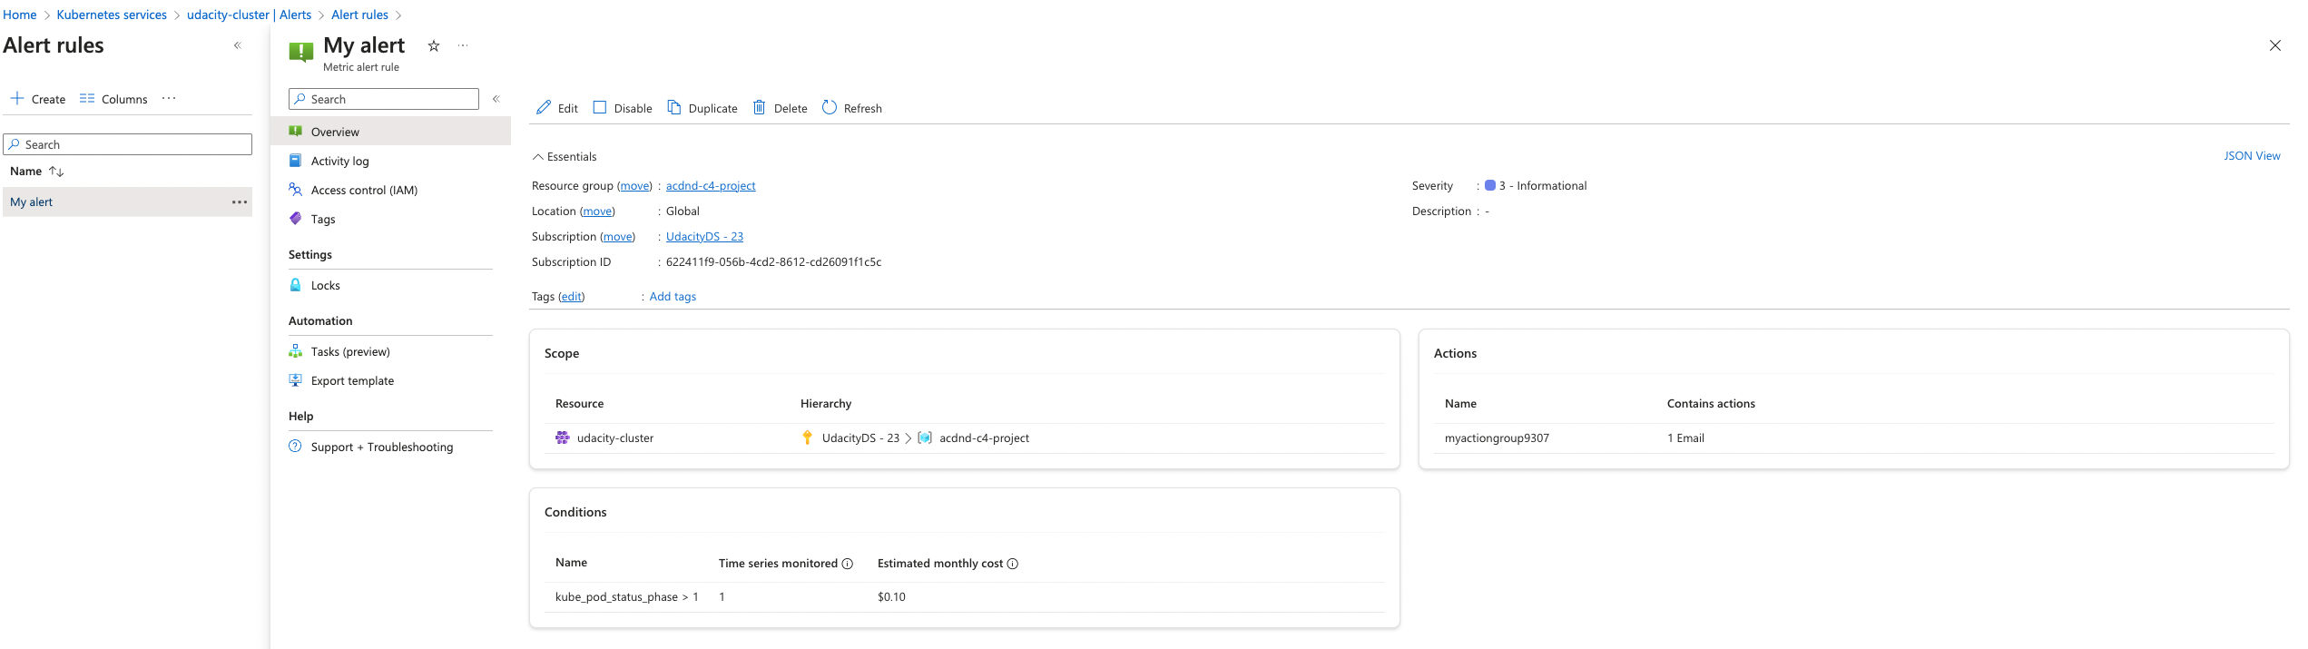  
   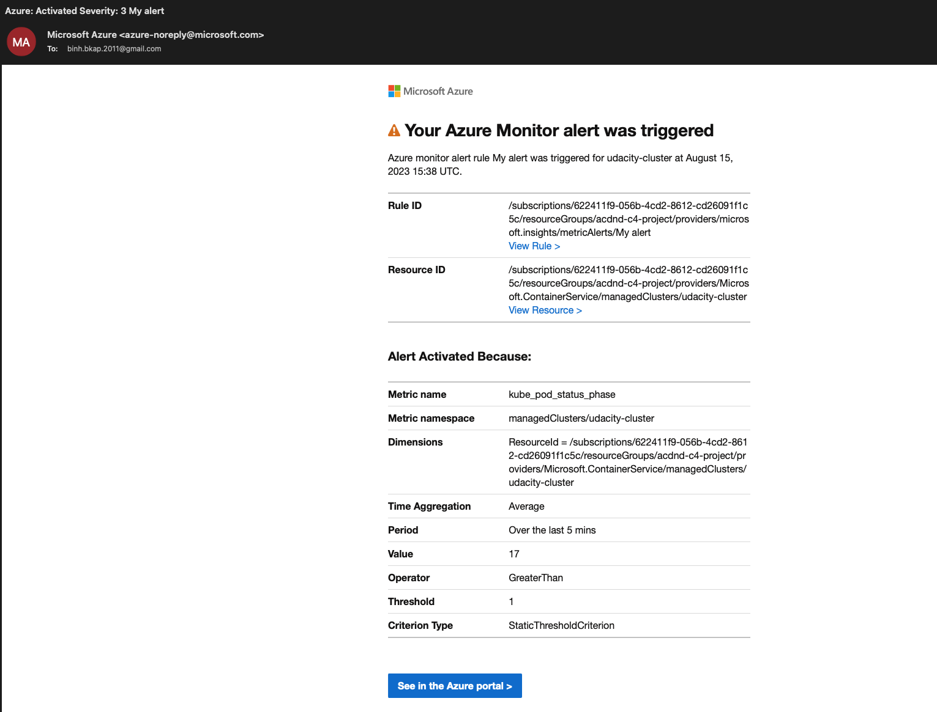
3. Create a horizontal pod autoscaler and cause load on the container. As evidence, provide screenshots showing:
   * The output of the Horizontal Pod Autoscaler, showing an increase in the number of pods.  
     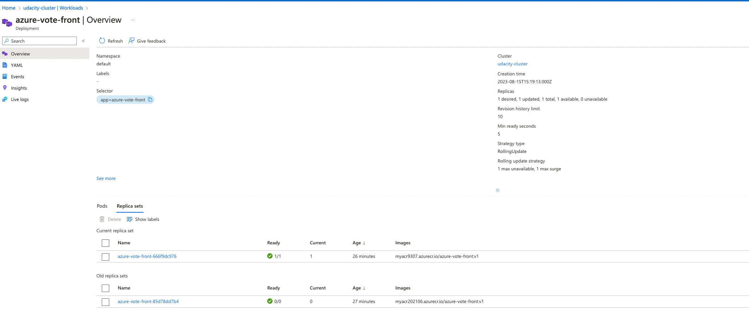
   * The Application Insights metrics which show the increase in the number of pods.  
     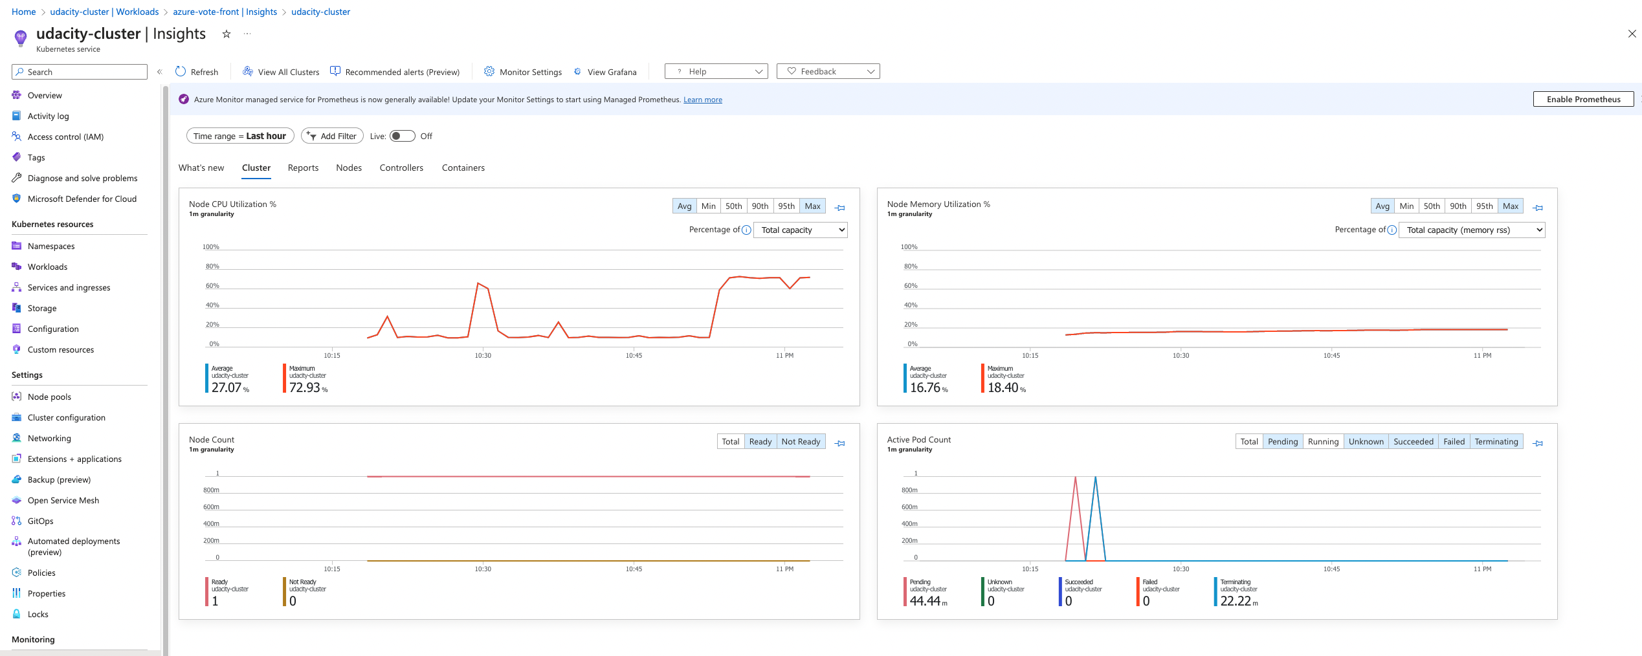
   * The email you received from the alert when the pod count increased.  
     

**Section 5. Automate Resolution of Performance Issues**

**Note**: Place the following screenshots in the */submission-screenshots/runbook* directory.

1. Provide a screenshot of your resource group containing your Azure Runbook and other resources.
2. Provide a screenshot showing Azure Alert configuration in Azure Monitor to trigger the RunBook.
   * The alert configuration in Azure Monitor should shows the resource, condition, action group (this should include a reference to your Runbook), and alert rule details (may need 2 screenshots).  
       
     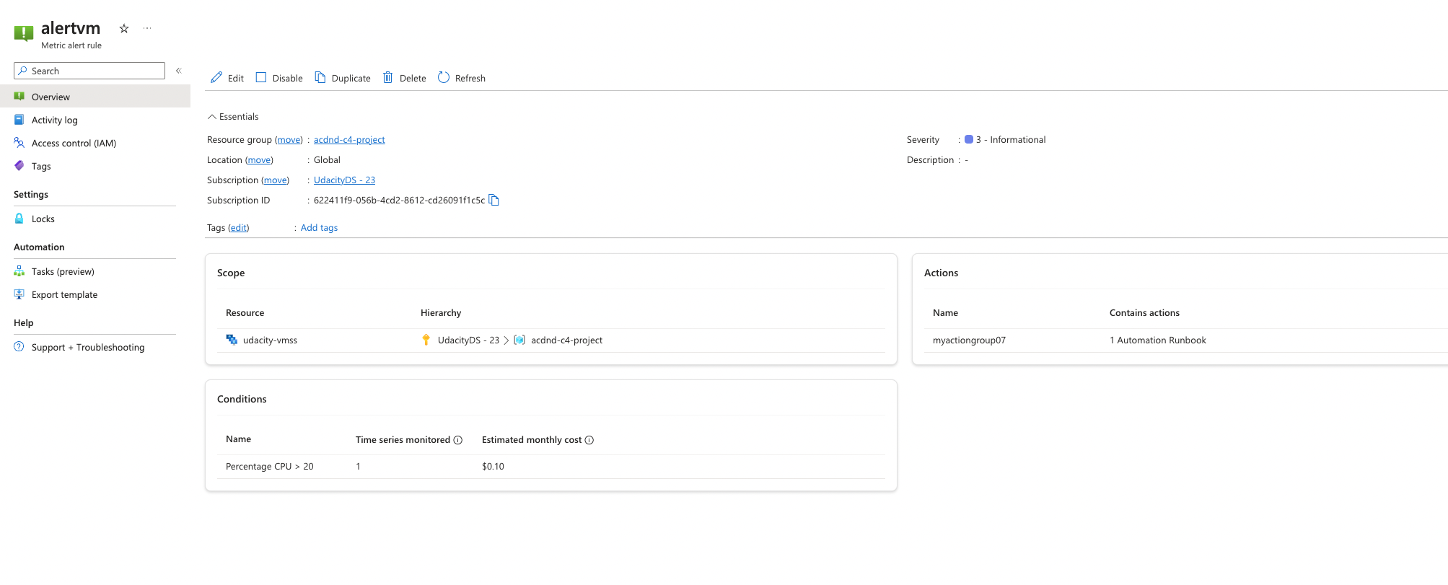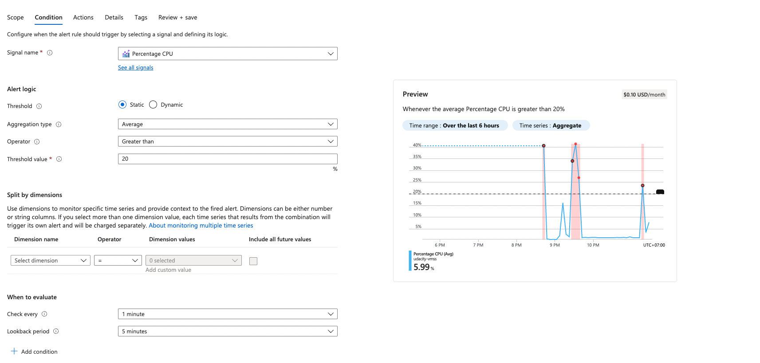
3. Finally, you will trigger the Azure Alert. The RunBook should execute and resolve the issue. Provide the following screenshots for the Azure Runbook which include:
   * The email you received from the alert when the Runbook was executed.  
     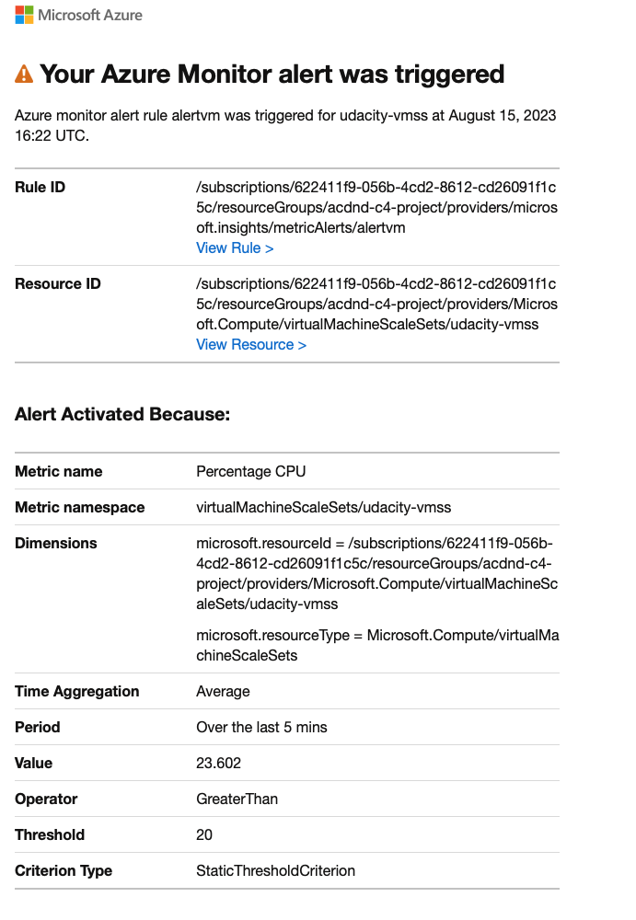
   * The metrics or other evidence showing the RunBook executed and resolved the issue.  
     